Team 1

LEGP21A

To the Chief Legal Council’s Office:

I am writing to report on the raised concerns about our legal position to prosecute unauthorized access. We are happy to report that the information team has taken steps to harden our position and make clear that unauthorized access to our systems is not tolerated and enable legal proceedings.

In order to achieve this objective, we have created banners on all access points to the internal network that explicitly state our position that any non-authorized access to the network will be prosecuted by the legal team. We created a process to force acknowledgment of the banner in order to log in as well.

Please find attached screenshots of the aforementioned login banners running in our code.

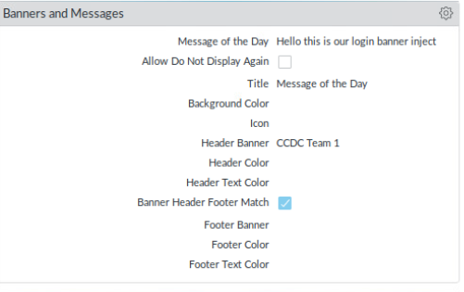

If you have any questions or need further information, please do not hesitate to reach out.

Best regards,

Group 1 Information Team